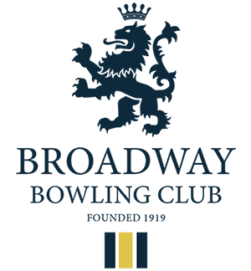Centenary Sprint Singles -Two Wood - Monday 27th May
Open to ALL Bowling Members.
All entrants will be drawn at random into Leagues. Each entrant will play the other members of the league over 5 ends. No trial ends. The winner based on total points scored, will be awarded 3 points. Ties will be awarded 1 point.
When all matches are concluded the winners of each League, plus the highest scoring runners up will advance to the Quarter Finals. The competition then becomes straight head to head knockout. Semi Finals and Final will be played over 7 ends. Prizes will be awarded for all bowlers reaching the Quarter Finals.
A consolation competition for entrants not reaching the Quarter Finals will be organized on the day. This will be a Knockout event for teams of two drawn on the day, again 2 woods per player over 5 ends. Prizes for Winners and Runners up.
Entry cost is £2.00. Pay on the day at registration. Entries close 17th May.
Register at 10.00am, play to commence at 10.30am prompt. All entrants will be required to act as scorers / markers for matches in their respective Leagues.
Bring a Picnic lunch. Tea and biscuits available and cakes will also be available in the afternoon.

Sponsored and supported by
Simon the Painter
Majestic Wines Stratford on Avon Drakes Pride Bowlswear Direct Cotswold Distillery

Proposed Prize Structure
Winner Trophy and £20 Bowlswear Voucher
Runner up £10 Bowlswear Voucher
2 Losing semi Majestic Bottle of wine
4 Losing Quarter Drakes Pride Measure, Towel, Scorecard and Grip wax

1st Consolation To be decided
Runners up Consolation Drakes Pride Towel and gripwax

Raffle Boules set- raffle, £10 Bowlswear Voucher, Cotswold Distillery Voucher, Majestic Prosecco

